



5 kWp on-grid Roof top solar power System

Power will be feed into 220V distribution line



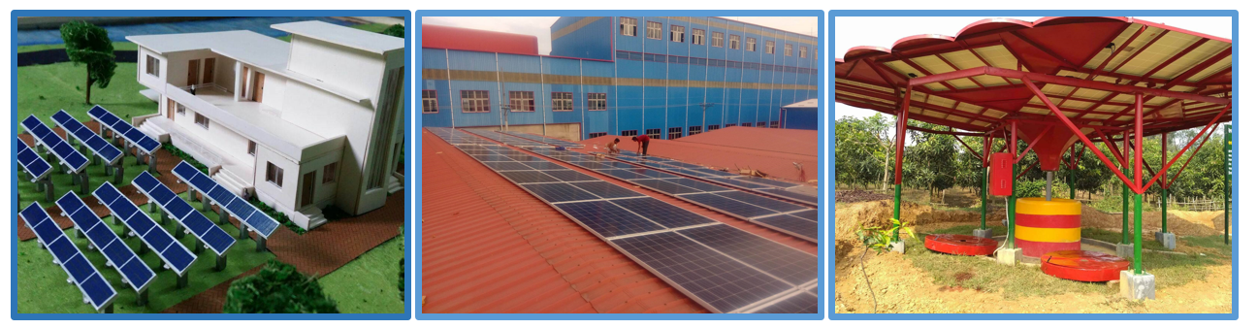

March 6, 2018

G-TECH SOLUTION LTD

5 kWp On-Grid Solar System

FINANCIAL OFFER

**Ref:** GTSL/RTS/5/06032018/01 **Date**: 06/03/18

**To,**

Khandakar Mahbub Alam

11, South bounari road,

Nowmahal, Mymensingh.

**Subject:** Quotation for Supply, Installation, Testing and Commissioning of **5 kWp** On Grid Solar System.

Dear Sir,

**GTSL** is one of the top professional solar engineering firm and also a leading importers of Solar Panel, Solar accessories (LED lights AC/DC, LED Street Light, Solar Pump, Charge Controller, On Grid/Off Grid Inverter). We are qualified solar power EPC provider in all over the Bangladesh. During our journey lots of completed solar power energy systems have been installed which are functioning smoothly.

Understanding from a reliable source that your august organization is keen to install Solar System at your rooftop premises, we are pleased to enclose herewith a proposal including technical and financial offer of the total project as per your requirement.

If you have any further queries or clarifications, please feel free to contact us. If need be, our technical personnel would meet you and explain issues that are relevant and you are interested to know. Thanking you and looking forward to receiving your positive response.

Yours sincerely,

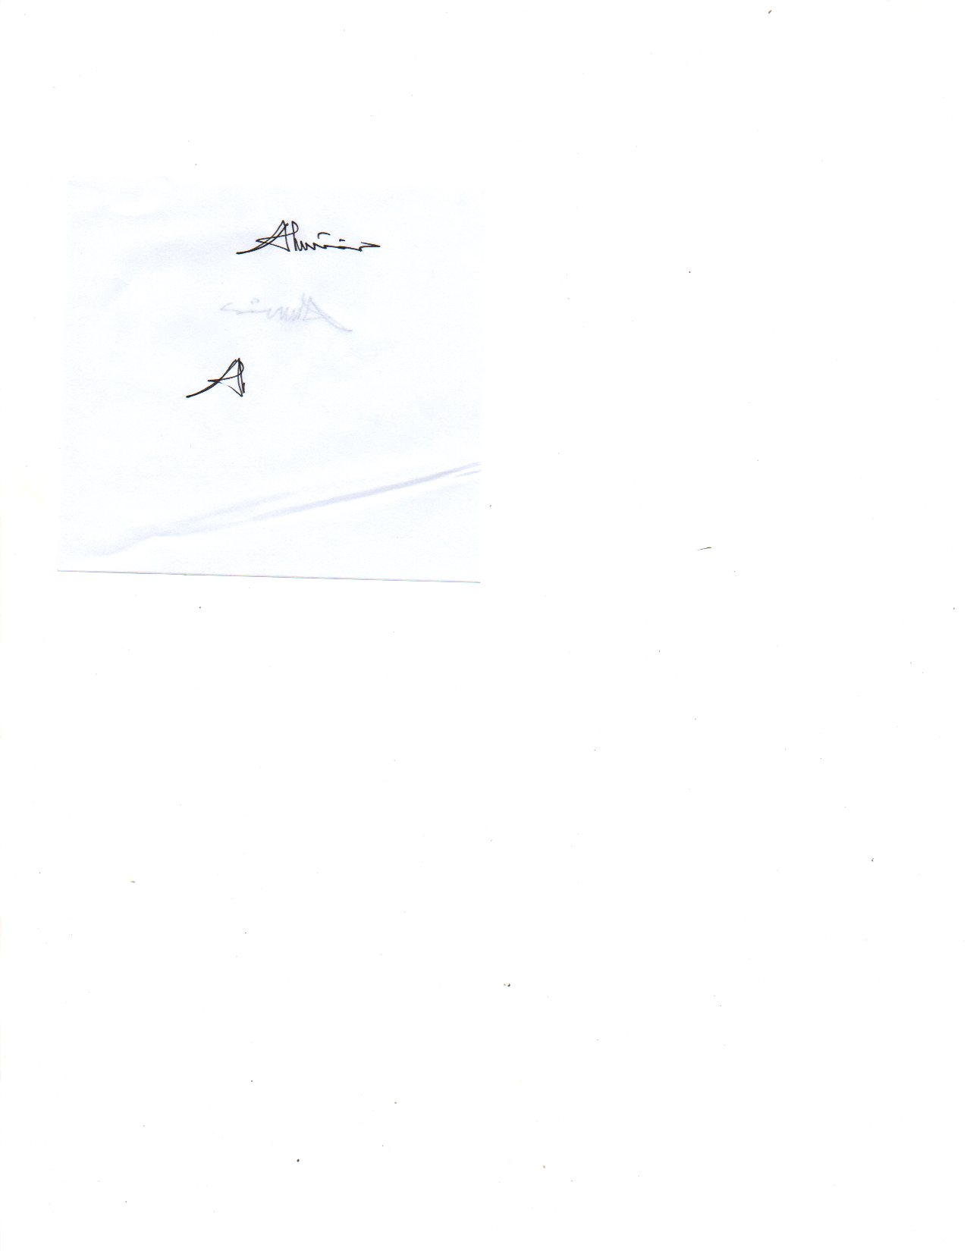

Shakil Ahmed

Assistant Manager

G-Tech Solution Limited

01766684111

**Financial Offer for 5 kWp**

|  |  |  |  |  |
| --- | --- | --- | --- | --- |
| **Item** | **System Specification** | **Quantity** | **Per Watt Price** | **Price (Tk.)** |
| Single Phase  Solar System | 1. **Solar panel**     1. No of panel: 20 Pcs    2. Brand –CNBM    3. Type – Poly Crystalline    4. Capacity: (250 Wp)/ 60 cells    5. Total Capacity: 5 kWp    6. Country of Origin: **China** | **1 set** | **60.00 Tk**  **X**  **5000Wp** | **3,00,000/=** |
| 1. **Cable**     1. Brand: Citizen/SQ/Paradise or Similar    2. Size: As Required   **c.** Country of Origin: **Bangladesh** |
| 1. **Panel Structure**     1. MS structure    2. Size: 1.5” x 1.5” x 3mm    3. Setup by required size Royal Bolt with L Based Angle.    4. Red Oxide with Aluminum Coated    5. Without RCC    6. Country of Origin: **Bangladesh** |
| 1. **On Grid Inverter**     1. Number of Inverter: **1** (5 kW)    2. Brand – Clou Or Similar    3. Total Capacity: 5 kW    4. Single Phase    5. Country of Origin: **China** |
| 1. **Energy Meter**     1. Quantity: 1 NOS    2. Single Phase    3. Brand: Cell/Electro    4. Country of Origin: **Bangladesh** |
| 1. Transport and Labour |
| 1. Testing & Commission |
| In words: Three Lac Taka Only | | | | |

Per watt Price 60.00 Tk only

*Validity: 30days after submission

# Warranties Policy & Period:

|  |  |
| --- | --- |
| Item | Warranty Period |
| PV panels | 25 years |
| Inverter | Standard 5 years |
| Structure | 2 years |

# General Terms & Conditions:

G-Tech Solution warranties do not cover normal wear and tear of the products or cost related to the removal, installation or troubleshooting of the customer’s electrical system. The warranties do not apply to and G-Tech Solution will not be responsible for defect or damage to:

* The product if it has been subject to fire, water, generalized corrosions, biological infestations, acts of God or input voltage creates operation conditions beyond the maximum or minimum limits listed in the BTEL product specifications concluding high input from generator.
* The product if repairs have been done to the other company than G-Tech.
* The product if its original identification (trademark, serial number) makings have been defaced, altered or removed.
* The product if it has damaged in lighting. The product if it has damaged by Acts of GOD.

Terms & Conditions:

* FREE SERVICE: 1 (One Year)
* Training: Train to technical personal for monitor & maintenance the system.
* **TAX & VAT: Excluding**.
* Project timeline / duration maximum *30 days* from the work order.

# Payment Condition:

* 50% of total ordered value to be made at the time of confirmed work order and rest 50% after successful Installation, Testing & Commissioning at site. Payments to be made in favor of “G-Tech Solution Ltd.” by A/C payee/ Cash etc. Or as per mutual agreement between two parties.

Appendix

# Solar Panel Catalog

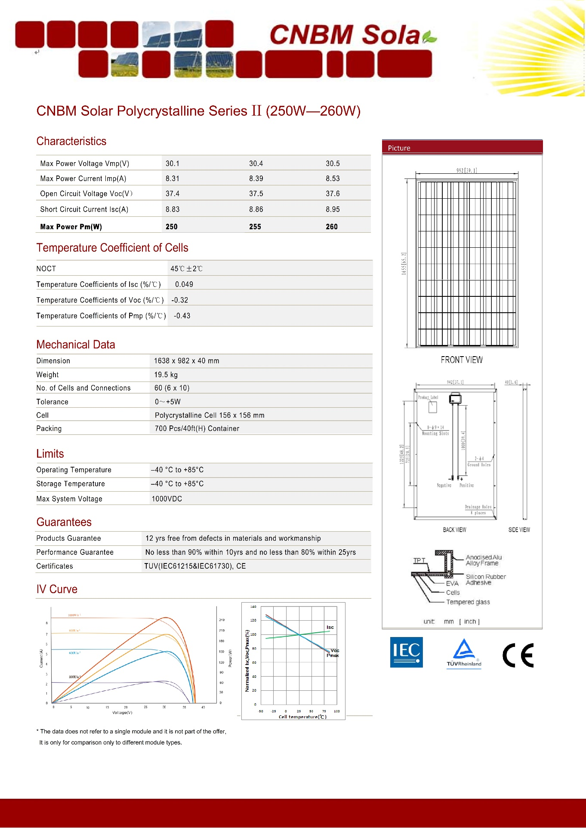

# Inverter Catalog

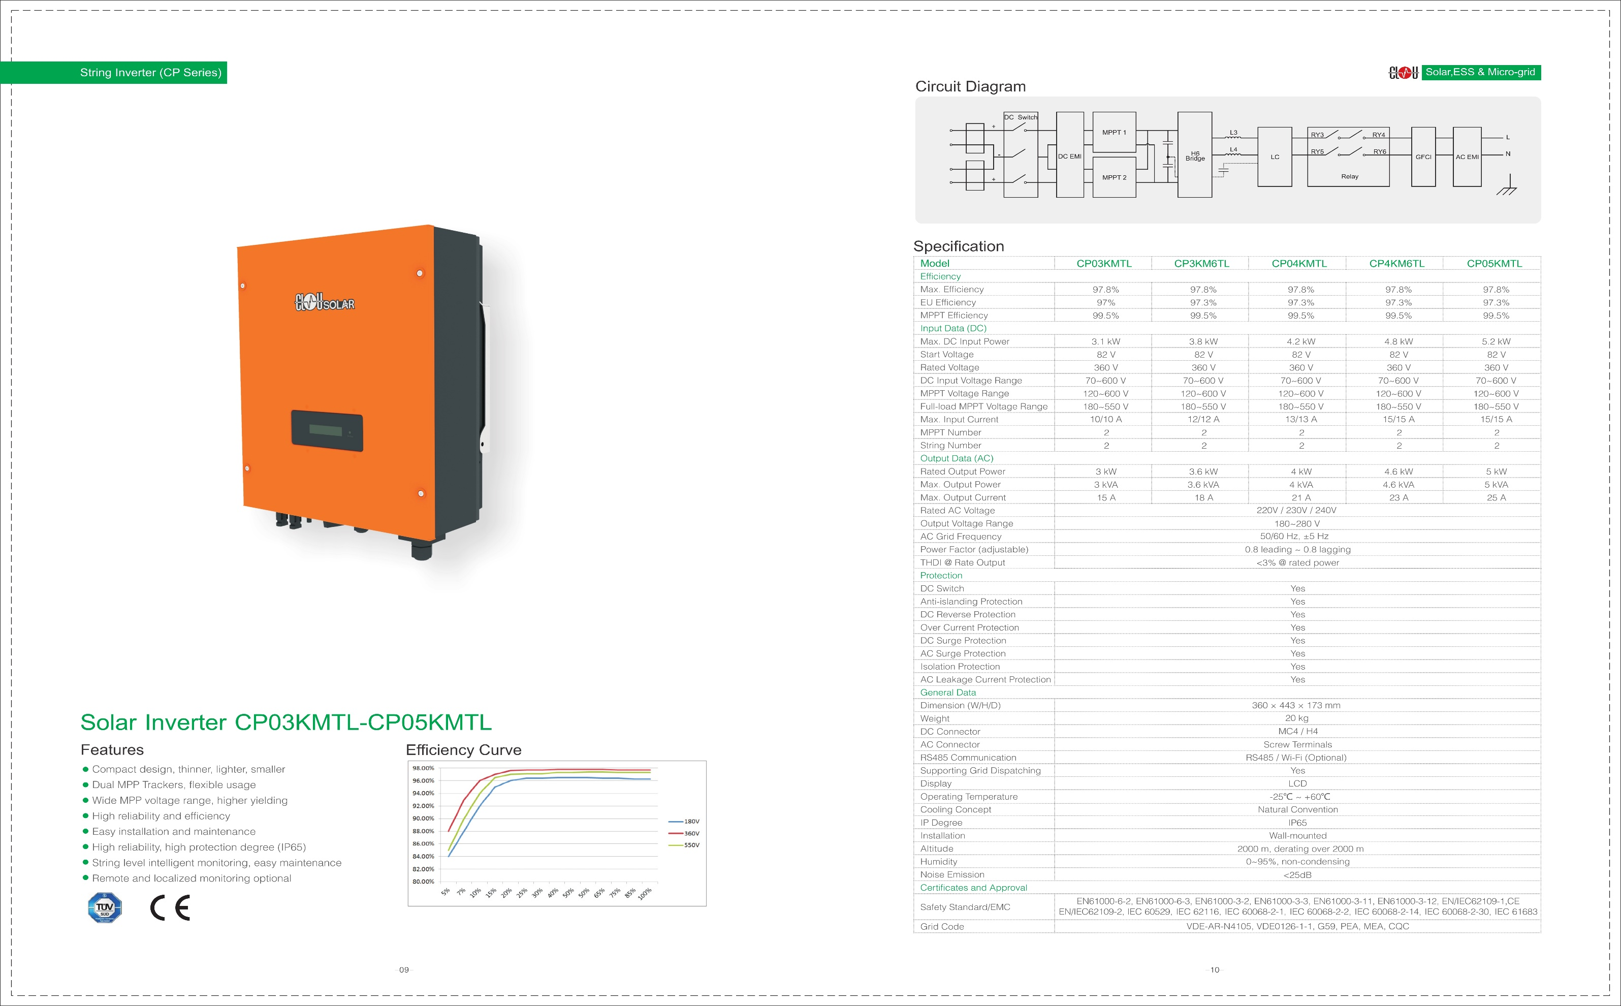

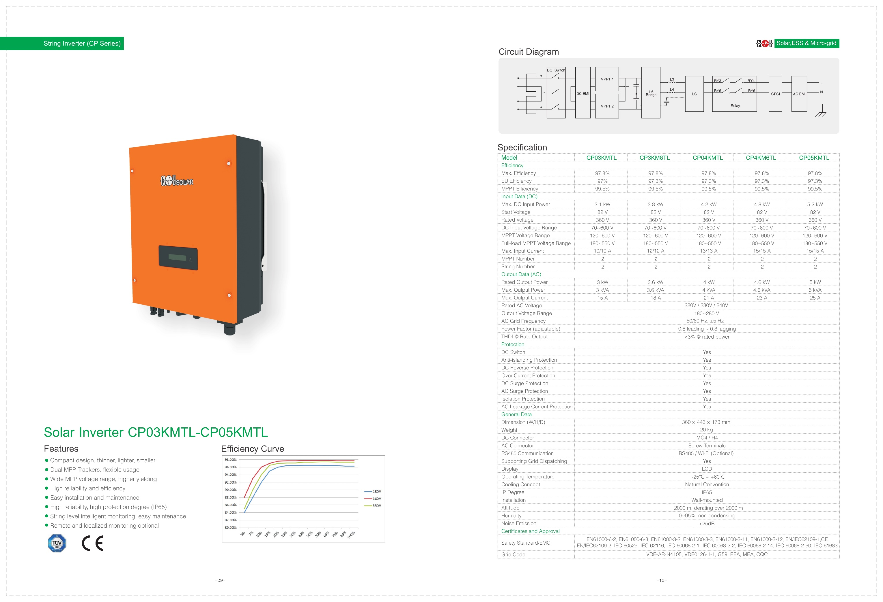

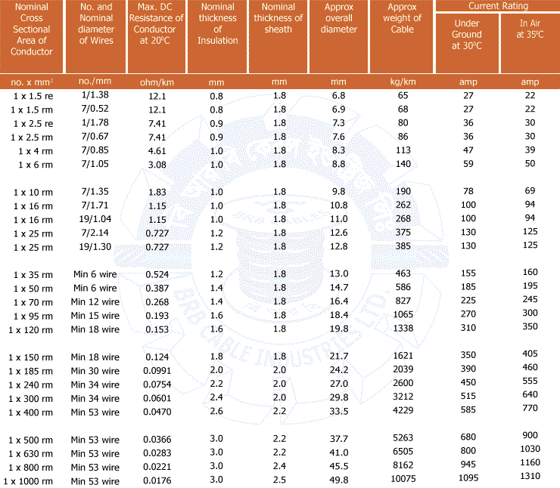**Wire Catalog**

# MC4 Catalog